الجامعة الإسلامية للتكنولوجيا

UNIVERSITÉ ISLAMIQUE DE TECHNOLOGIE

ISLAMIC UNIVERSITY OF TECHNOLOGY

DHAKA, BANGLADESH

ORGANIZATION OF ISLAMIC COOPERATION



**CSE 4412**

**Data Communication and Networking Lab**

**Lab-03 Report**

**Name :** Tahsin Islam

**Student ID :** 210042137

**Department :** Computer Science and Engineering

**Program :** B.Sc. in Software Engineering

**Semester :** Summer 2022-2023 ( 4th )

**Submission Date :** 07/02/2024

**Task-01**

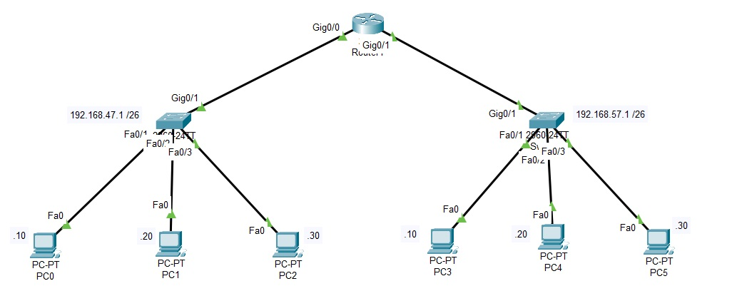

Fig 1.1: Topology

**Step 1: Set the IP Address**

As I can connect a maximum of 37 (last 2 digits of my ID) hosts per network, in the last octet of the Subnet we will need 5 bits for the host address (26=64), and the first 2 bits of the last octet will be part of the network address.

**Subnet:** 255.255.255.192

**IP range of the first subnetwork:** 192.168.47.1 – 192.168.47.64

**Default gateway of subnetwork 1st subnetwork:** 192.168.47.1

**IP range of the second subnetwork:** 192.168.57.1 – 192.168.57.64

**Default gateway of subnetwork 2nd subnetwork:** 192.168.57.1

The screenshots of two PCs of each network are given below:

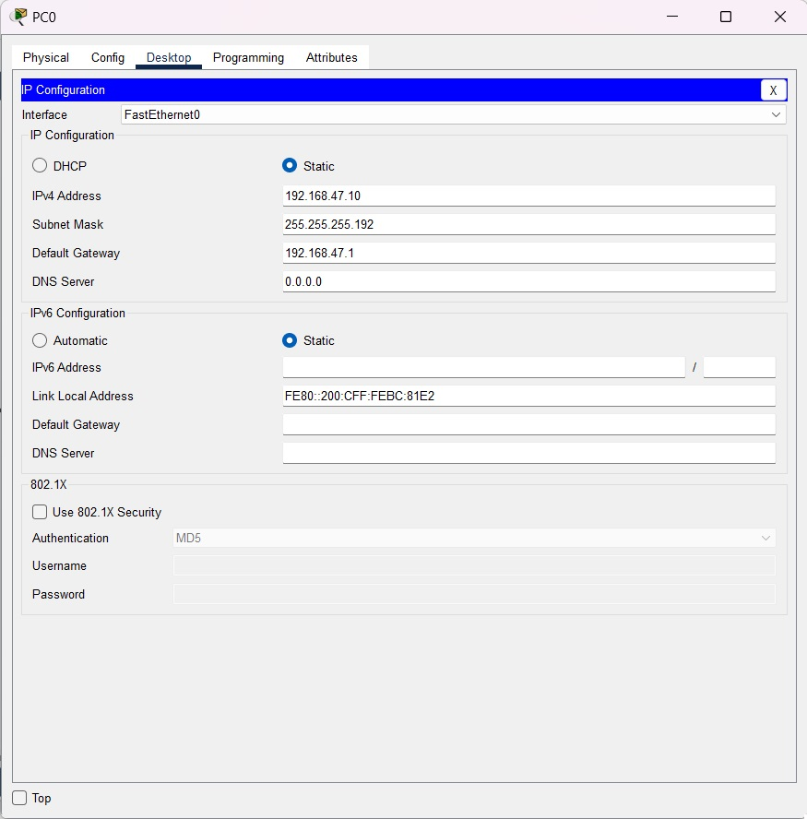

Fig 1.2: IP Address of PC0

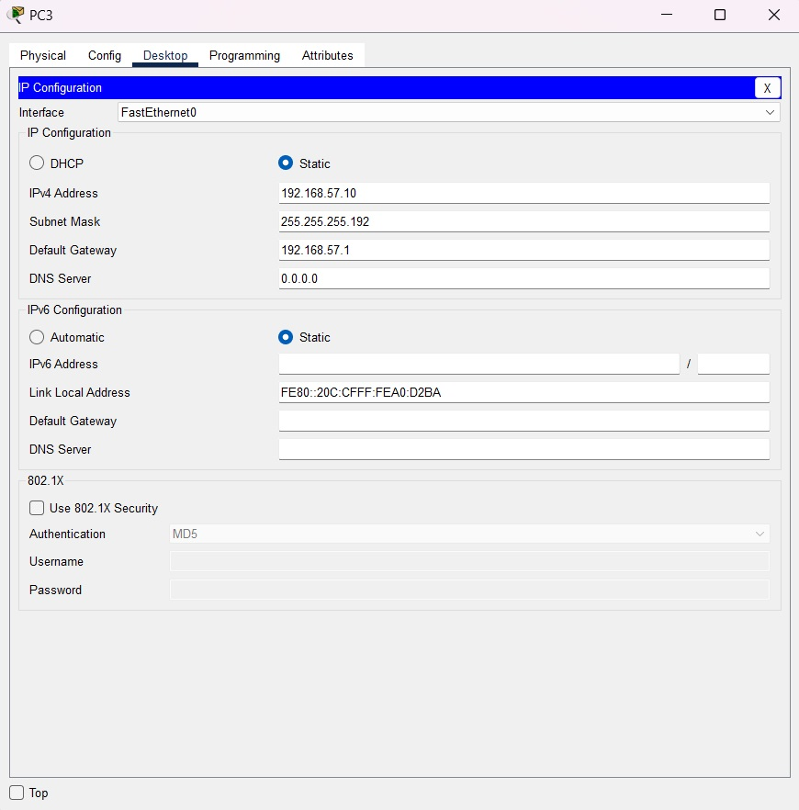

Fig 1.3: IP Address of PC3

**Step 2: Router Configuration**

To configure the router, I clicked on the router and went to CLI. Ther used the following commands:

|  |
| --- |
| Router# enable  Router# config t  Router(config)# interface gigabitEthernet 0/0  Router(config-if)# ip address 196.168.47.1 255.255.255.192  Router(config-if)# no shutdown  Router(config-if)# exit  Router(config)# interface gigabitEthernet 0/1  Router(config-if)# ip address 196.168.57.1 255.255.255.192  Router(config-if)# no shutdown  Router(config-if)# exit |

Here is the screenshot of the commands:

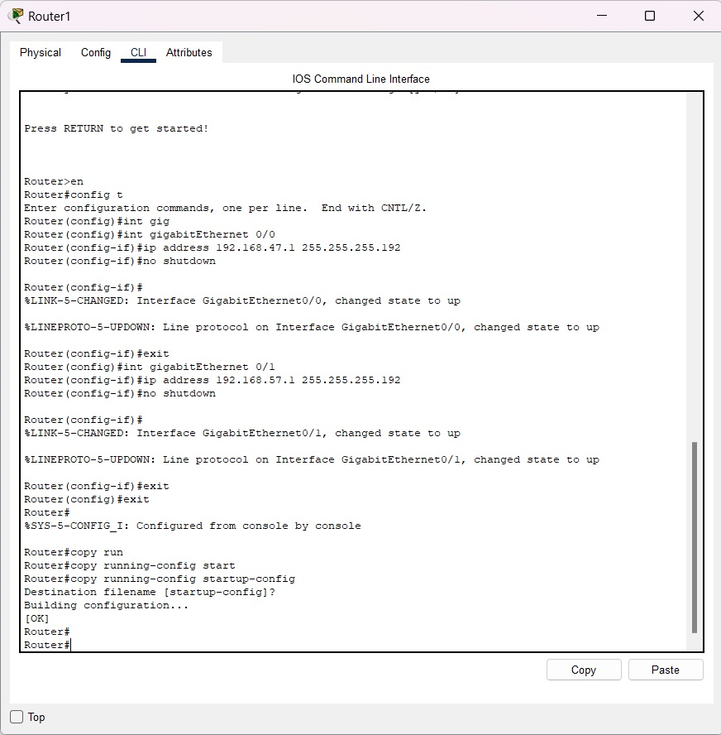

Fig 1.4: Router configuration

**Step 3: Using the ping command from the Terminal**

To ping, I clicked on PC0, went to Desktop, then Command Prompt. In the command prompt, I wrote:

|  |
| --- |
| Ping 192.168.57.10 |

Here is the screenshot of this step:

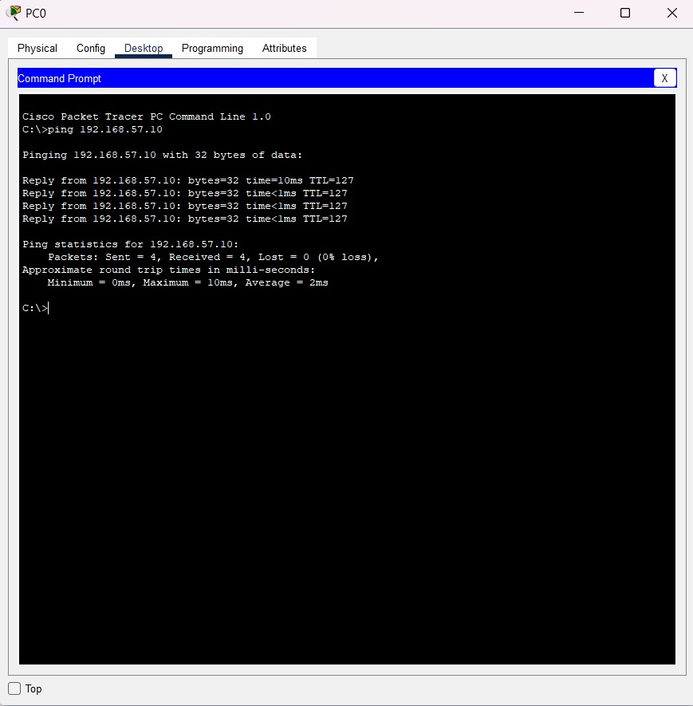

Fig 1.5: Command Prompt of PC0

We can see that 4 packets were sent, 4 packets were received, and 0 packets were lost.

**Task-02**

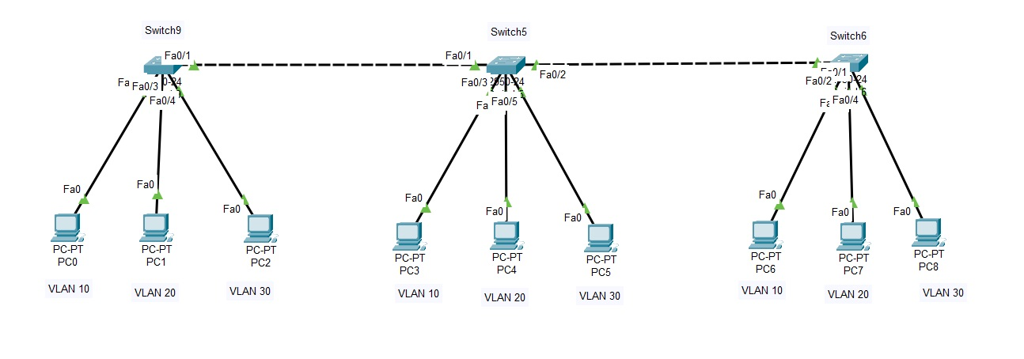

Fig 2.1: Topology

**Step 1: Configuring Switches**

At first, I configured 3 VLANs with VLAN IDs 10, 20, and 30 inside the switch and assigned appropriate names. To do this, I have used the following commands:

|  |
| --- |
| Switch> enable  Switch# config t  Switch(config)# vlan 10  Switch(config-vlan)# name student  Switch(config-vlan)# exit  Switch(config)# vlan 20  Switch(config-vlan)# name teacher  Switch(config-vlan)# exit  Switch(config)# vlan 30  Switch(config-vlan)# name admin  Switch(config-vlan)# exit |

Then I configured the Interfaces belonging to each VLAN. For that, I used the following commands:

|  |  |
| --- | --- |
| Switch(config)# interface fastEthernet 0/2  Switch(config-if)# switchport mode access  Switch(config-if)# switchport access vlan 10  Switch(config-if)# no shutdown  Switch(config-if)# exit  Switch(config)# interface fastEthernet 0/3  Switch(config-if)# switchport mode access  Switch(config-if)# switchport access vlan 20  Switch(config-if)# no shutdown  Switch(config-if)# exit | |
| Switch(config)# interface fastEthernet 0/4  Switch(config-if)# switchport mode access  Switch(config-if)# switchport access vlan 30  Switch(config-if)# no shutdown  Switch(config-if)# exit  Switch(config)# interface fastEthernet 0/1  Switch(config-if)# switchport mode trunk  Switch(config-if)# switchport trunk allowed vlan all  Switch(config-if)# no shutdown  Switch(config-if)# exit |

This way I have configured the interfaces. For Switch6, the commands are exactly same as Switch9. There is a bit of difference in Switch5.

|  |
| --- |
| Switch(config)# interface fastEthernet 0/3  Switch(config-if)# switchport mode access  Switch(config-if)# switchport access vlan 10  Switch(config-if)# no shutdown  Switch(config-if)# exit  Switch(config)# interface fastEthernet 0/4  Switch(config-if)# switchport mode access  Switch(config-if)# switchport access vlan 20  Switch(config-if)# no shutdown  Switch(config-if)# exit  Switch(config)# interface fastEthernet 0/5  Switch(config-if)# switchport mode access  Switch(config-if)# switchport access vlan 30  Switch(config-if)# no shutdown  Switch(config-if)# exit  Switch(config)# interface fastEthernet 0/1  Switch(config-if)# switchport mode trunk  Switch(config-if)# switchport trunk allowed vlan all  Switch(config-if)# no shutdown  Switch(config-if)# exit  Switch(config)# interface fastEthernet 0/2  Switch(config-if)# switchport mode trunk  Switch(config-if)# switchport trunk allowed vlan all  Switch(config-if)# no shutdown  Switch(config-if)# exit |

As Switch5 has 2 trunk connections that’s why the changes in the command.

Here are the screenshots of the three switches:

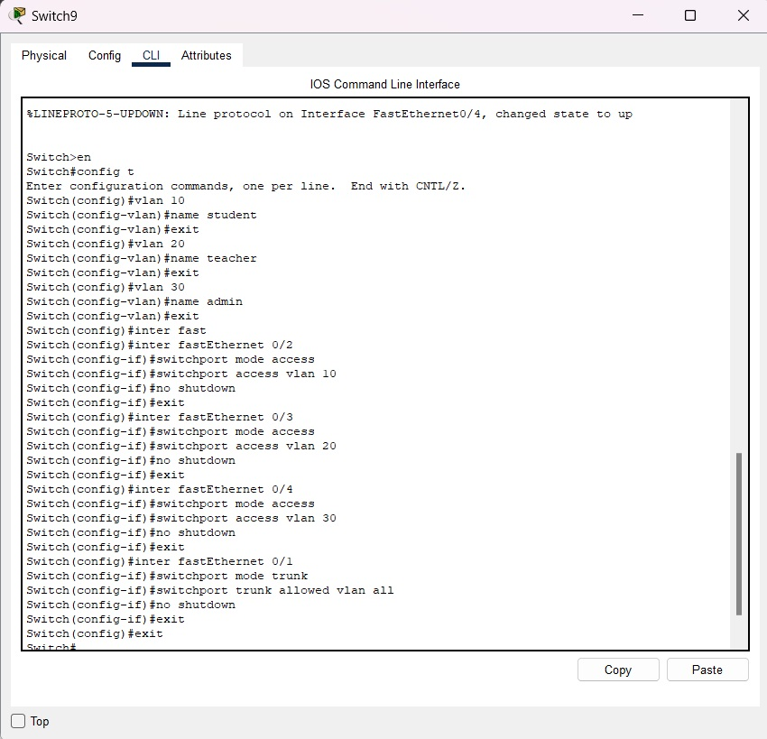

Fig 2.2: Switch9 configuration

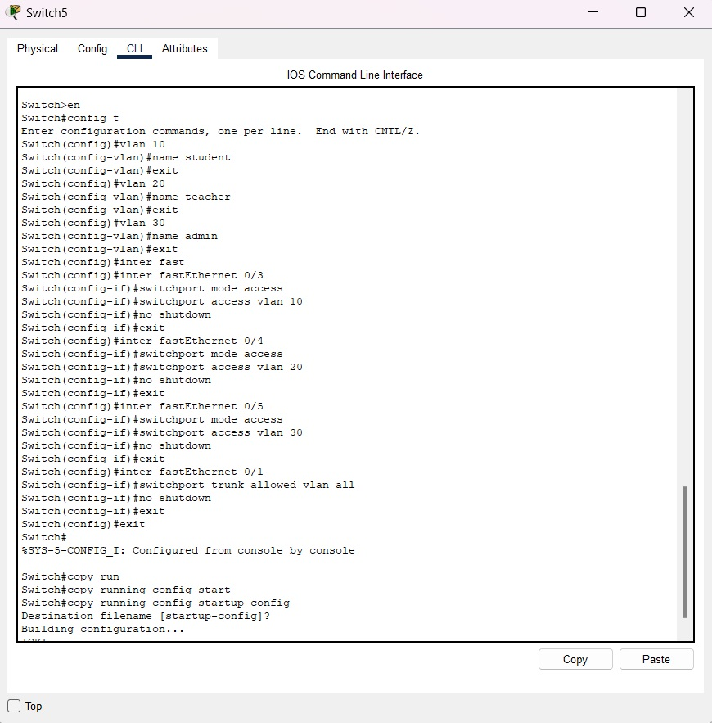

Fig 2.3: Switch5 configuration

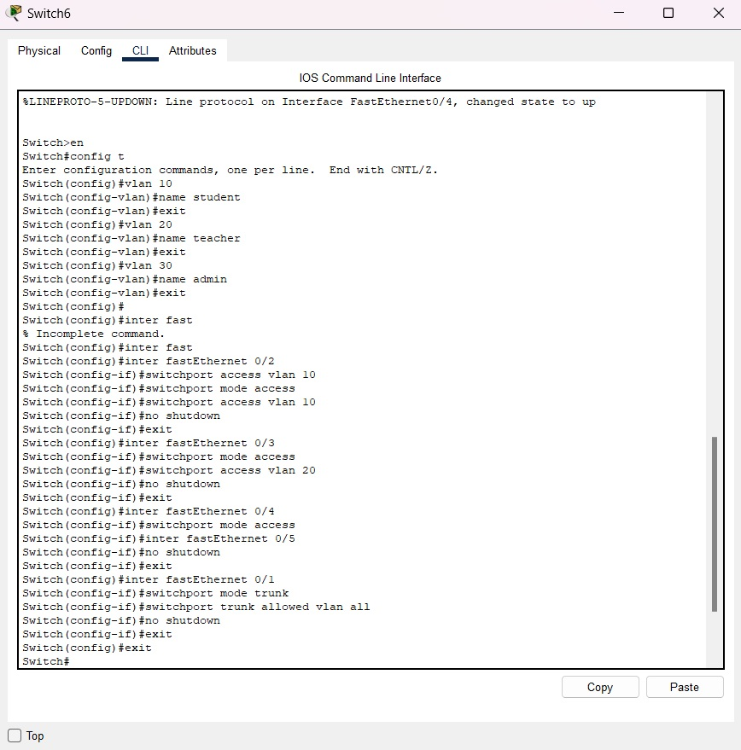

Fig 2.4: Switch6 configuration

**Step 2: Setting Up IPs**

As my ID’s last 2 digits are 37, IP addresses have started from 192.167.47.1.

But for all the VLAN 10 hosts, I have set their IP address with the last digit 2, for VLAN 20 hosts, last digit is 3, and for VLAN 30 hosts, last digit is 4.

VLAN 10 host’s IP address:

1. PC0: 192.167.47.2
2. PC3: 192.167.47.12
3. PC6: 192.167.47.22

VLAN 20 host’s IP address:

1. PC0: 192.167.47.3
2. PC3: 192.167.47.13
3. PC6: 192.167.47.23

VLAN 30 host’s IP address:

1. PC0: 192.167.47.4
2. PC3: 192.167.47.14
3. PC6: 192.167.47.24

Here are the screenshots:

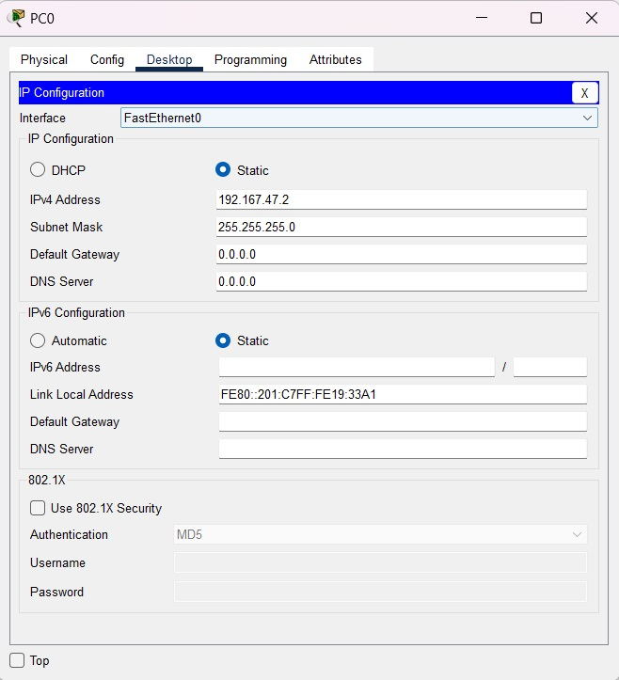

Fig 2.5: IP Address of PC0

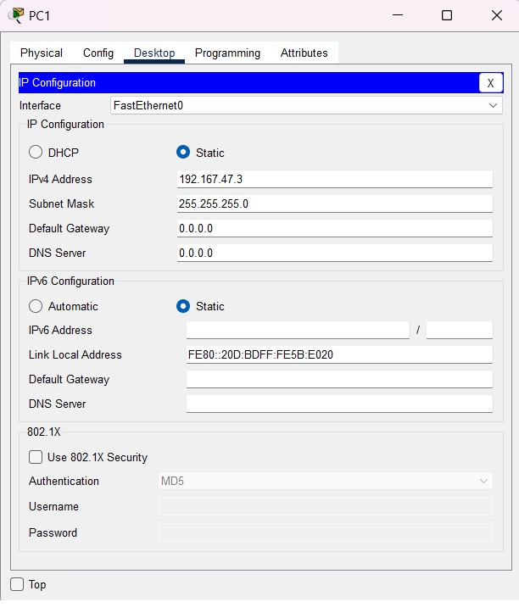

Fig 2.6: IP Address of PC1

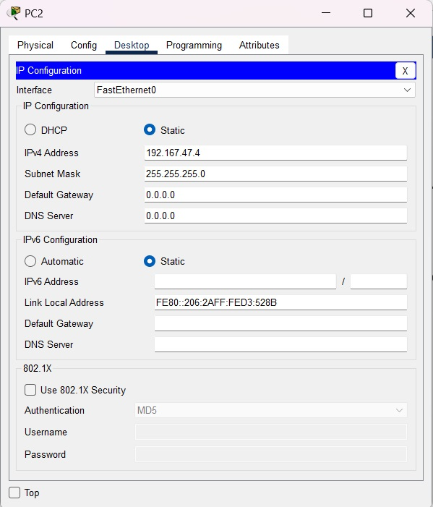

Fig 2.6: IP Address of PC2

**Step 3: Using the ping command from the Terminal**

To ping, I clicked on PC0, went to Desktop, then Command Prompt. In the command prompt, I wrote:

|  |
| --- |
| Ping 192.167.47.12 |

We saw that 4 packets were sent, 4 packets were received, 0 packets were lost as they are on VLAN 10.

But when I sent a ping to PC6 using this:

|  |
| --- |
| Ping 192.167.47.24 |

We saw that, 4 packets were sent, 0 packets were received, 4 packets were lost as they are on different VLANs.

Here is the screenshot of the command prompt of PC0:

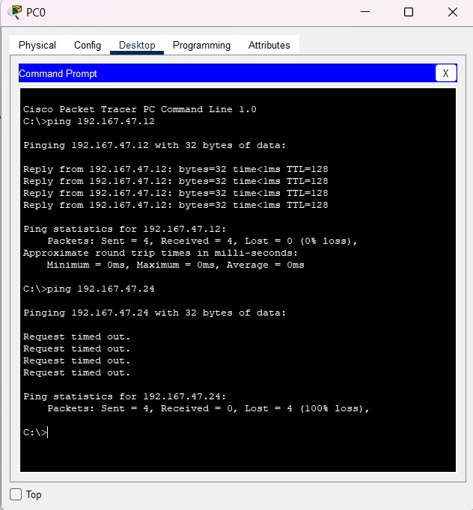

Fig 2.7: Command Prompt of PC0

### **Questions (Answer to the point)**:

* + - 1. How many host bits are needed in the largest required subnet?

**Ans:** 6 bits.

* + - 1. How many VLANs need to be configured to each of the switches?

**Ans:** 3 VLANs.

* + - 1. Which interfaces need Access Link?

**Ans:** Interfaces that are connected with PCs.

* + - 1. Which interfaces need Trunk Link?

**Ans:** Interfaces that are connected with another switch.

* + - 1. After configuring VLAN, what will happen if we broadcast?

**Ans:** After configuring VLANs, broadcast traffic will only be forwarded within the same VLAN, limiting its scope.

### **Challenges (if any):**

No challenge faced.